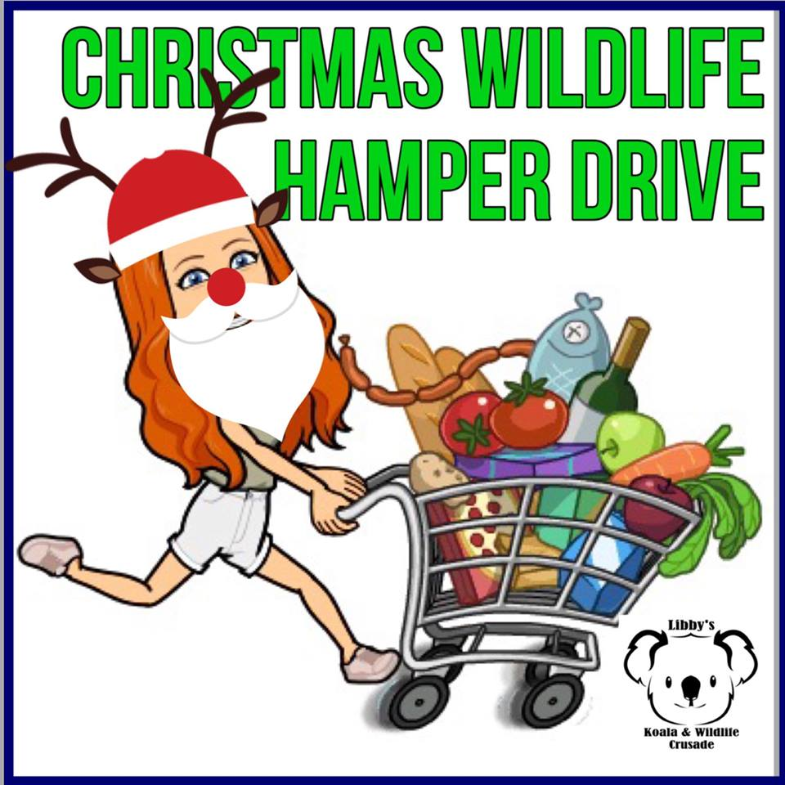
If you can help with ANY of these items-
It would be awesome!!
Add an item to your
trolley each week?
Items needed by Christmas
16 Parook Court, Diamond Creek
Hi, My name is Libby and I am 14 years old.
Since I was 11, I have been raising money and
awareness for the rescue and rehabilitation of our wildlife. I try and help volunteer shelters, carers and rescuers by supporting them with- money donations, pouches, everyday items like these, enclosures, equipment- anything I can do, I basically do! I am thankful to have some amazing support from my family, community and online followers. This Christmas, I am collecting every day grocery items that help with rehabilitation of our wildlife. It’s mainly cleaning items as looking after wildlife can get messy! These items will be shared between 8 wildlife shelters. Buying these items will mean that carers can use their money for vet bills, fuel, utilities, special medications and foods and much more. Together, buying little things like this, will make a big difference. Some items are brand specific- this is because carers use some items and prefer the brands mentioned.
If you can’t buy the items yourself and deliver to me (at 16 Parook Court, Diamond Creek)- you are welcome to “Donate 2 Buy” and I will do the shopping for you.
There are two ways to do this
Bank Deposit  Libby Fisher  BSB: 063 594  AC: 1040 1537  Ref: Donate 2 Buy | PayPal  https://paypal.me/libbyskoala  crusade?locale.x=en_AU

Please see my Wish List over the page- Thank you!
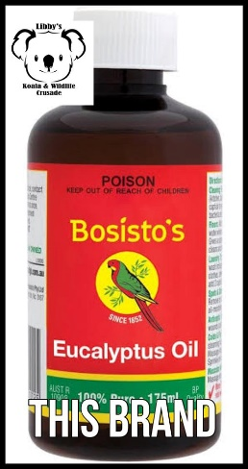 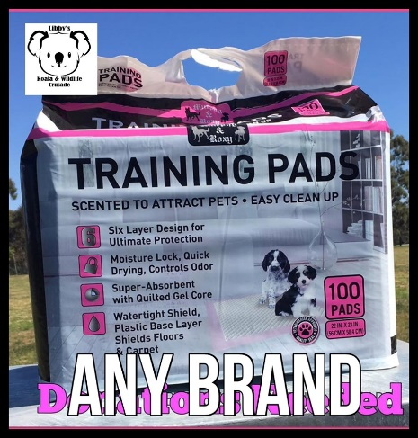 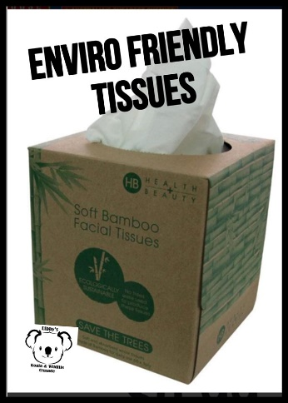 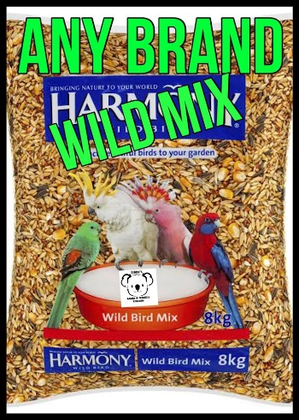
Eucalyptus Oil Puppy Pads Environmentally Friendly Tissues WILD Bird seed mix
for cleaning for enclosures of sick or injured for toileting animals feed
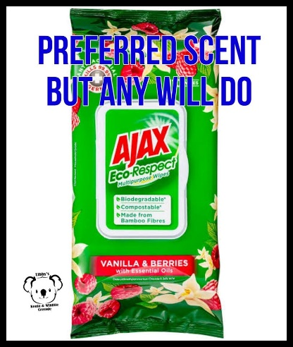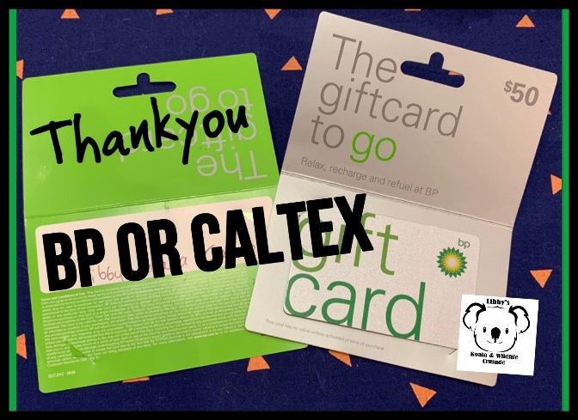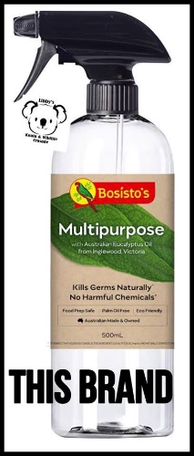
Cleaning wipes BP or Caltex Fuel Vouchers THIS BRAND cleaning spray
cleaning enclosures for rescuers for cleaning/disinfecting Aussie owned
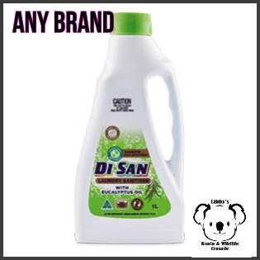 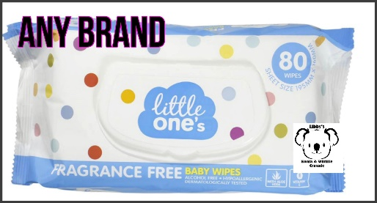 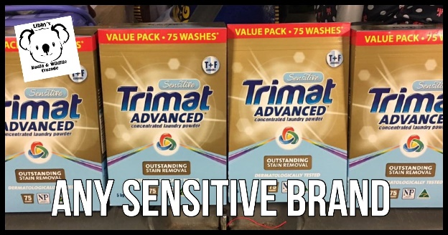
Hygiene wash baby wipes any brand unscented Only Washing powder- sensitive brands only
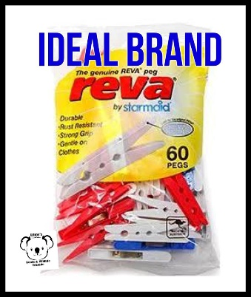 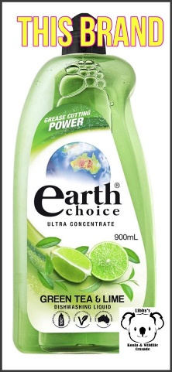 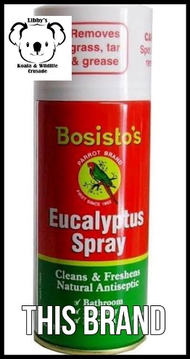 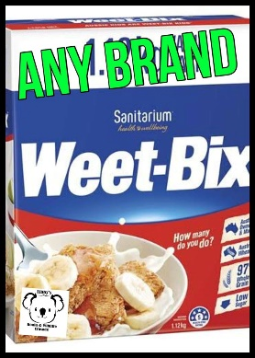 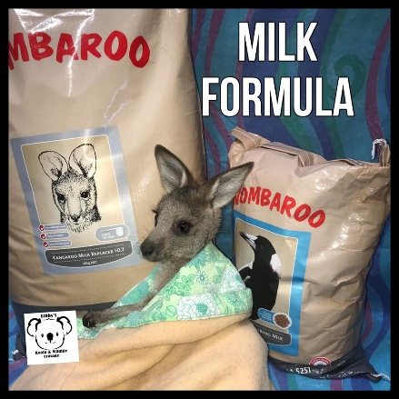
Pegs for washing Dishwashing liquid SPRAY any brand DONATE ONLINE TO HELP BUY THIS
enviro friendly USED a LOT Kangaroo/Wombat treats

